Required Test Equipment

- M1-3200 Bed-of-nails test fixture
- PC with M1-3200 test software installed
- Label printer
- Barcode scanner
- USB Cable,Type A to Type B
- Ethernet cable

Functional Test Procedure

- Start the test fixture software
Double click M1-3200 launcher icon on the left side of the Desktop screen
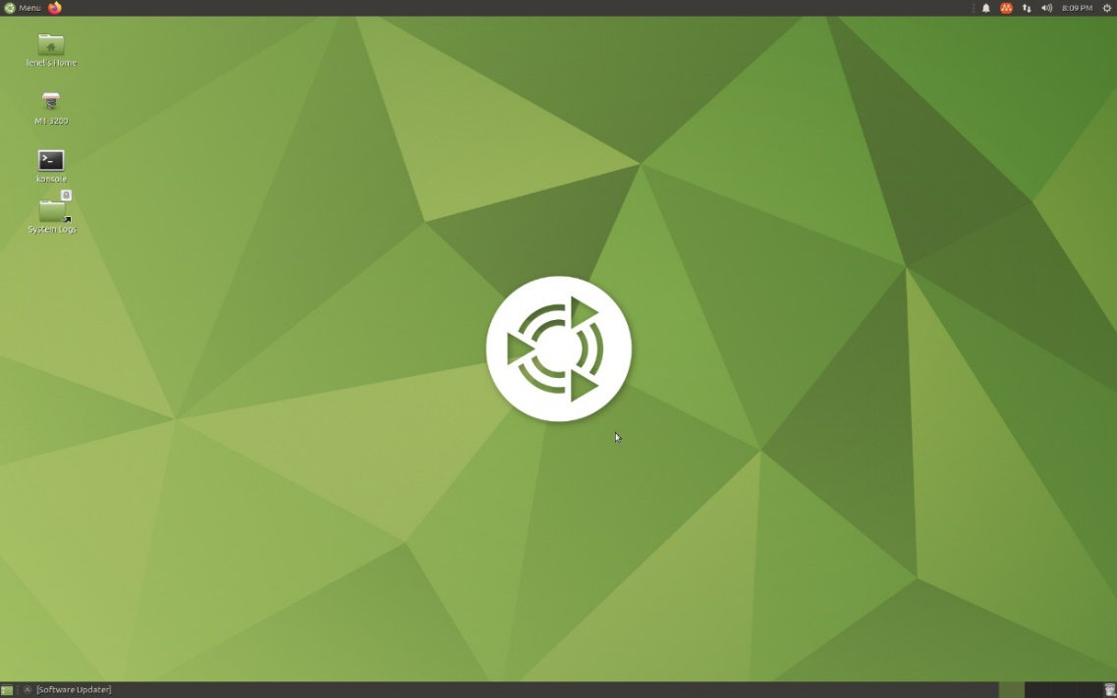

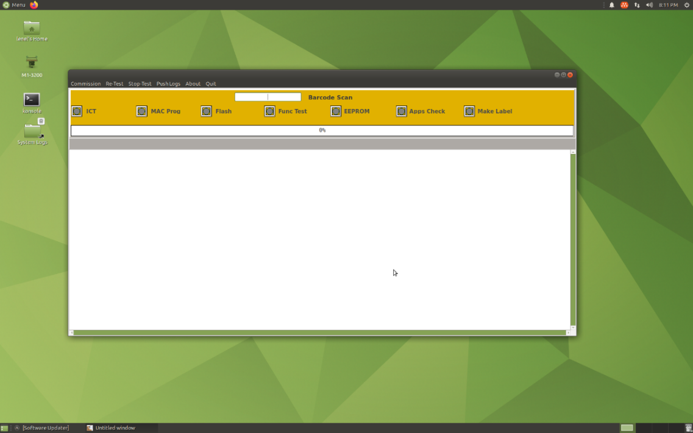

- Open the test fixture cover.
Move the cover lever on the right site to the vertical position.
Using the cover handle on the front side of the fixture open the top cover

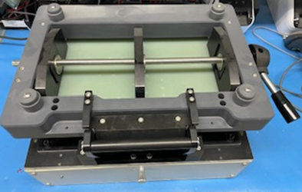

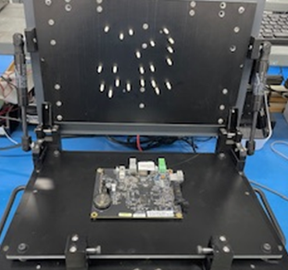

- Place the M1-3200 board into the test fixture

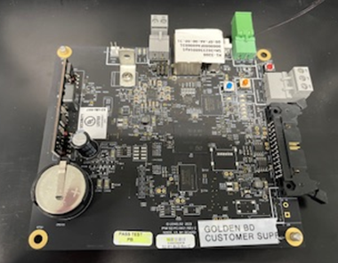

- Scan the Serial Number barcode (the board front edge as shown above)

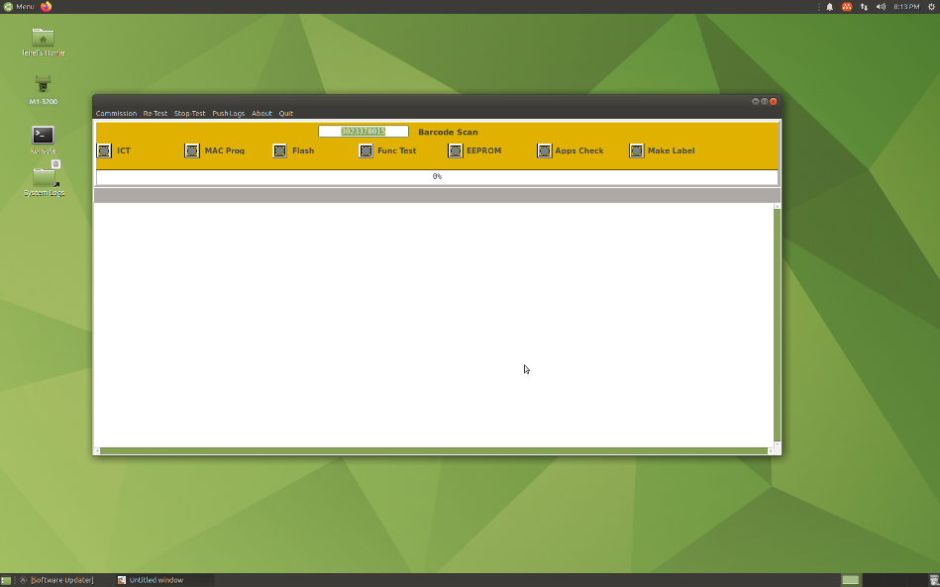

- Close the test fixture cover.
Make sure to latch the lever handle on the side of the test fixture to the horizontal position.

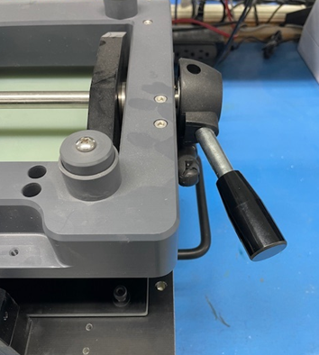

The Green LED shall be on when the latch lever is locked.

- Press the desired action, Commission or Re-Test
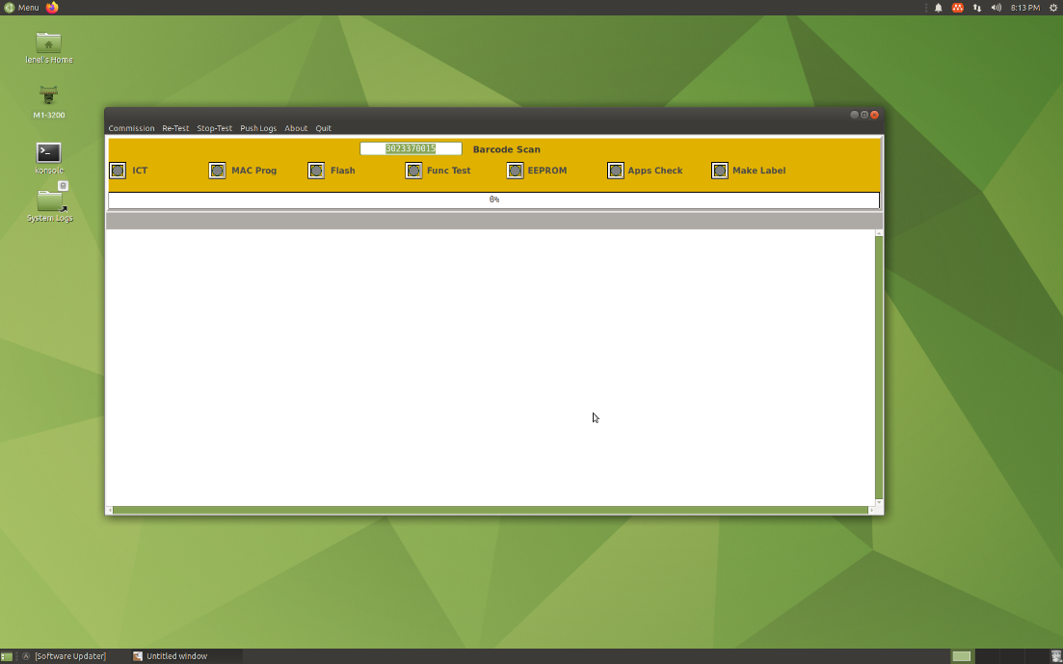

- Wait until test is complete

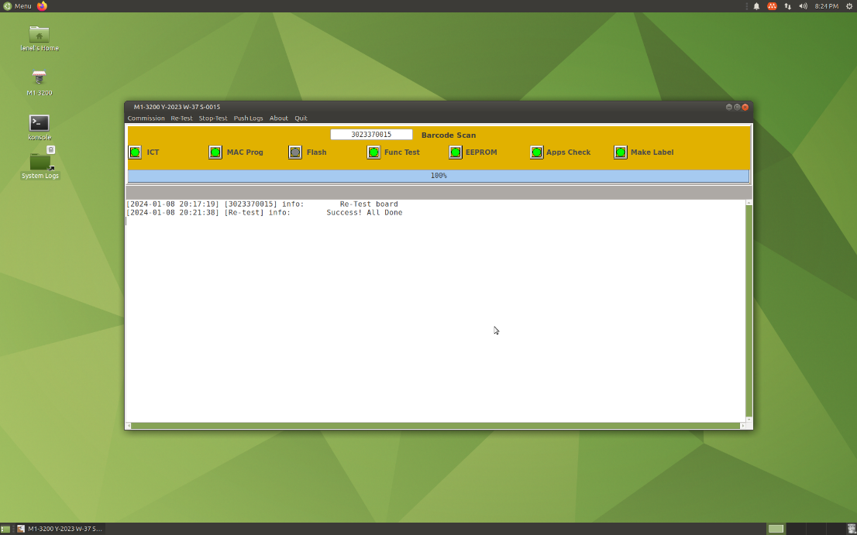

When complete the label is printed

Revision History
Date Version Reason/Description Author
03/08/2024 A Initial Release T. Newman

